
2026-27 Curriculum Overview
 | Autumn 1 | Autumn 2 | Spring 1 | Spring 2 | Summer 1 | Summer 2
Topic for the term | Changes through the year | Little me, Big me! | Super senses | Toy stories | Passport to Shanghai | Footprints around the world
Trip |  | Rose theatre production at school based on fairytales (enquired but not confirmed) |  | Young V&A to explore toys that date back to the 1600s (not confirmed)
English | 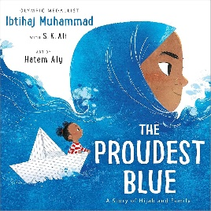  The proudest blue by Ibtihaj Muhammad | 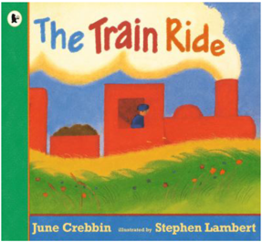  The train ride by June Crebbin | 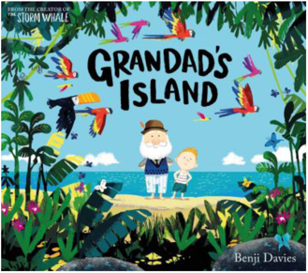  Grandad’s Island by Benji Davies | 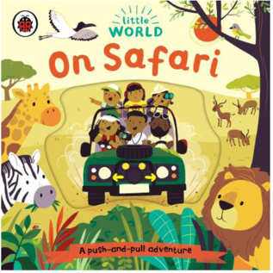  On Safari | 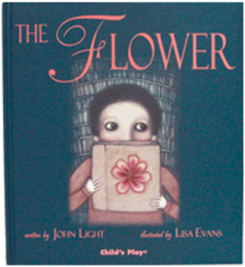  The Flower by John Light | 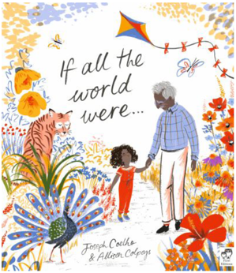  If all the world were… by Joseph Coelho
Maths | Place value | Addition and subtraction | Measurement | Multiplication and division | Fractions | Geometry
Science | Forces and space: seasonal changes | Everyday materials  Forest school | Animals: sensitive bodies  Forest school | Animals: comparing animals | Plants | Investigating science through stories
RE | Why did Jesus tell stories? | What is in our school’s name?  Who is who in the nativity? | Is easter the most important festival for Christians?  Why do Jewish people celebrate the gift of Shabbat? | Who are our Christian neighbours? | How does belonging to a synagogue help a Jewish person in their faith? | What teaches people to look after the world?
History |  | How am I making history? |  | How have toys changed? |  | How have explorers changed the world?
Geography | What is it like here? |  | What is the weather like in the UK? |  | What is it like to live in Shanghai?
Art | Exploring line and shape | Colour splash | Paper play | Paper play | Woven wonders | Woven wonders
Computing | Commands unlugged | Rocket to the moon | Bee-bots | Digital imagery | Data | Online safety
Music | Lewisham music
PE
PSHE/RSE | Families and relationships | Health and wellbeing | Safety and the changing body | Citizenship | Economic wellbeing | Transitions
MFL | Italian

2026-27 Curriculum Overview – Autumn 1 2026
 | Week 1 | Week 2 | Week 3 | Week 4 | Week 5 | Week 6
 | Changes through the year
Trip
English | The Proudest Blue  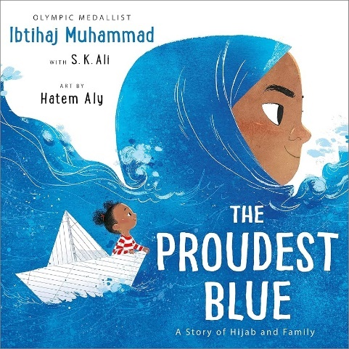
Maths | Place value
Science | Wonderful weather | Seasonal activities | How do trees change? | Daylight hours | Observing overtime | Weather reports
RE | Which stories are special to us and why? | Why did Jesus tell stories? | What does Jesus teach us through the Good Samaritan? | What does Jesus teach us through the parable of the Lost Sheep? | How do these parables help us to understand life and how we could behave? | How can we be teachers and share our stories?
Geography | Where in the world are we? | What can we see in our classroom? | What can we find in our school grounds? | Where are the different places in our school? | How do we feel about our playground? | Can we make our playground even better?
Art | Exploring line | Musical lines | Exploring shape | Shape in art | Klee portraits | Every picture tells a story
Computing | Command games | Computing commands | Following instructions | Creating instructions | Fixing instructions
Music | Lewisham music
PE | Miss Jamie and Forest School
PSHE/RSE | What emotions can we recognise? | When and why do people show different emotions? | How can emotions change? | What helps us to feel calm or excited? | What might make us feel worried, annoyed or upset? | What can we do when our feelings get tricky?
MFL | Italian

2026-27 Curriculum Overview – Autumn 2 2026
 | Week 1 | Week 2 | Week 3 | Week 4 | Week 5 | Week 6
 | Little me, Big me!
Trip
English | The Train Ride  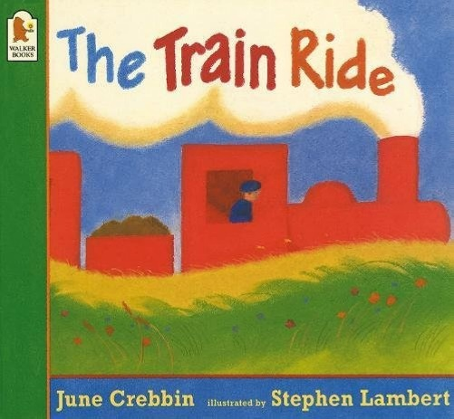
Maths | Addition and subtraction
Science | Naming materials | Material detectives | Introduction to properties | Is it absorbent? | Is it waterproof? | Is it tough?
RE | Who makes the promise? Who is the promise to?  Is it easy to make and keep a promise? | How can a promise be a sign of commitment?  What happened at Jesus’ baptism and why was he baptised? | What kinds of promises are made in a Christian baptism and why? | What kinds of promises are made at a Christian wedding and what does this mean for Christians? | How do promises help Christians feel closer to God? | What differences do promises make to me?
History | What is my history? | How can I find out more about myself? | How are special events remembered? | What have I learnt about childhood in the past? | How am I making history? | What does the poppy mean and why do people wear it?
Art | Making colours | Painting with colour | Printing with paint | Exploring colour mixing | Clarice Cliff plates | Clarice cliff plates
Computing | Rocket materials | Rocket designs | Rocket building instructions | Making a rocket | Making a rocket | Rocket launching
Music | Lewisham music
PE | Miss Jamie and Forest School
PSHE/RSE | What makes me special? | How do families show love and care for each other? | What helps me feel safe and cared for? | What is a friend? | How can we have a kind and friendly class? | How should people behave towards others?
MFL | Italian

