Year 1
Jane Goodall Class
Autumn 1 2026

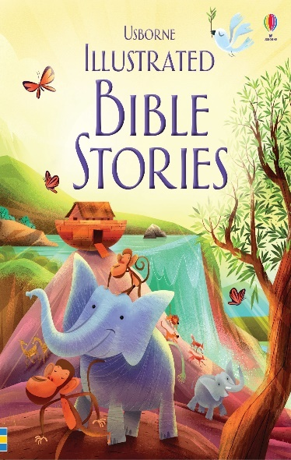

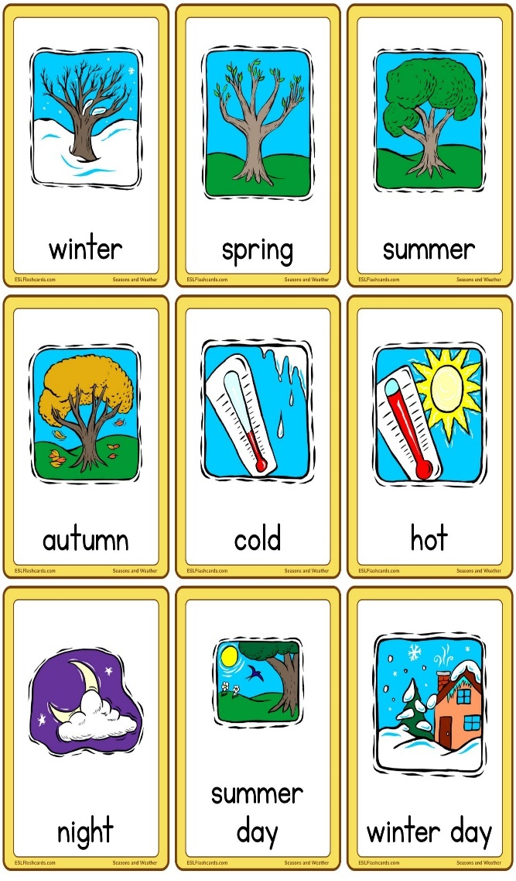
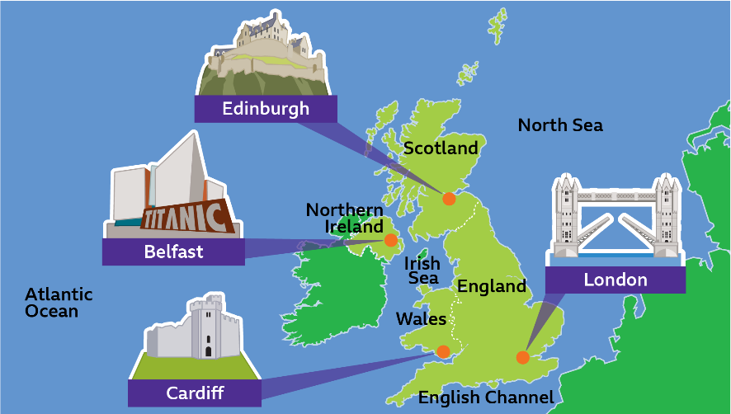
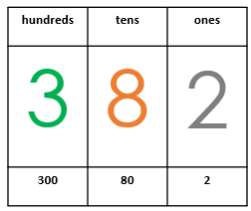
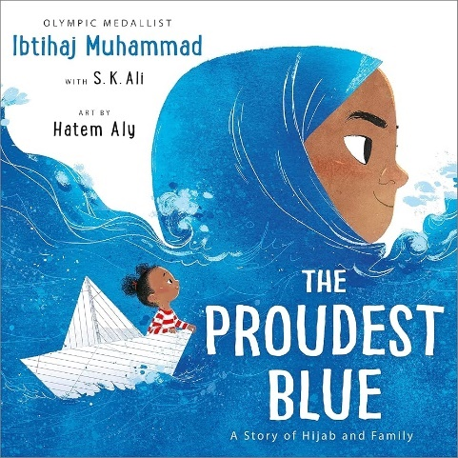
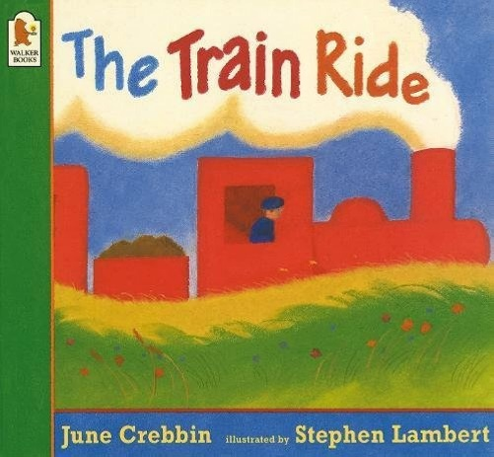
Dear Parents and Carers,

Welcome to year 1
During autumn 1 term, in English, we will be exploring the book ‘The proudest blue’ and will move on to ‘The train ride’. In maths, our topic for the half term is place value. In science, we will be exploring the seasons and weather. In RE, our topic is ‘Why did Jesus tell stories?’. In geography, we will be exploring our local area ‘what is it like here?’.
All the learning in this unit has been specifically designed to help your child achieve the skills outlined in the new national curriculum. Children will be reading, researching, writing, illustrating, working on their own and working in groups.
Please discuss with your child the learning they have done as the term progresses and let them teach you.
General Reminders
School starts at 8:40am. The class register will close at 8:50 am.
Children arriving after 8:50am will need to go through the office door and their arrival will be recorded in the late book.
If children arrive after 9.00 am they will be marked as late in the register. Please ensure that your child arrives to school on time every day, we start our learning as soon as the day begins.
Reading records
Reading happens 3x a week with a member of the year 1 team. Reading records will be checked and signed. Children will have their books changed once a week, this will consist of a book that is at your child’s level as well as a book that they would like to read at home with you. Please do engage with your child’s reading at home.
Absence
Please ensure that you contact the school to notify them of any absence from school and the reason for this. A phone call on the day is always appreciated.
Jewellery
For the safety of your child please ensure that they do not wear hoop or drop earrings, necklaces, rings or bracelets to school. Children will be asked to remove such items when at school. Small stud earrings are allowed.
P.E
PE takes place on a Tuesday (subject to change) with Miss Jamie. Please ensure your child is in full PE kit on this day.
Labelling Clothing
Please ensure that all clothing is labelled with your child’s name. We cannot be liable for lost or misplaced clothing that is not clearly labelled.
School lunches/Packed lunches
Please try to ensure that your child does not change their lunch option in the middle of the half term. This causes confusion for the office. If your child has a packed lunch please ensure that the food provided includes healthy options and forms a well-balanced lunch. No food containing nut, we endeavour to be a NUT FREE school.
Breakfast
Please ensure your child has a healthy breakfast and has a good start to the day.
Bedtimes
It is so important that your child goes to bed at a sensible time. A good night’s sleep will ensure they are ready energised and ready for learning.
Helping your child to learn … How you can help?
Spelling
The words below are common words, which your child will need to know, even to tackle very simple texts.
Learning these words early will help your child develop pace and accuracy in their reading and writing at an early stage.
There are many simple ways that you can help your child to learn these words at home. For example you
could…
- Read the words to your children as well as listening to them reading to you.
- Display the words around the house. This could be done by making labels to stick on cupboards, fridges and doors
- Play games like snap and matching pairs.
Below is a list of words children in Years 1 are expected to practise.
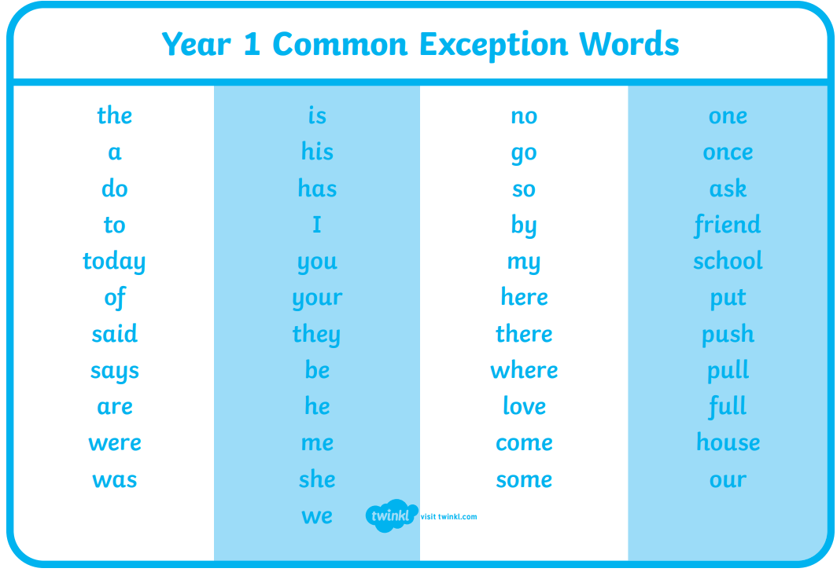

Maths
One of the most important elements in maths learning is for your child to have a clear understanding of numbers.
This includes them being able to …
- Count to 100
- Count in steps and skip in multiples of 2s, 5s and 10s.
- Read and write numbers up to 100, and write number words from 1-20.
- Find more or less.
- Compare numbers and use words like equal to, more than, less than, most and least.
- Use symbols: + - and =
- Number bonds to 20.
- Simple addition and subtraction problems using numbers up to 20.
- Recognise halves.
- Recognise quarters
It would be helpful if you could practice these skills at home with your child, revisiting these activities regularly to secure your child’s understanding.
By carrying out these simple activities you will be providing a huge boost to your child’s learning and progress over this coming year.
BBC bitesize has brilliant activities for all subjects taught in Year 1.
Class Dojo
As a school, each class has their own class dojo page which is constantly updated with activities the children have been getting up to in class. It is also a good way to communicate with the teacher if you have any questions. Any changes in class will be uploaded and sent on Class Dojo for parents to see as well as the children.
If you are yet to join the year 1 class dojo page, please let myself know and I will resend a link.
Home Learning
Home Learning is outlined below and will be set each Friday for return on the following Thursday at the very latest. The home learning will include 1 piece of English, spellings, a piece of maths and a piece of learning relevant to something we explored during the week.
We hope this pack gives you a clear understanding of what your child will be doing this term. We appreciate your support and if you need to discuss any matters with us, please feel free to ask any questions.

Thank you,
Mrs Winter-Khan and the rest of the Year 1 team
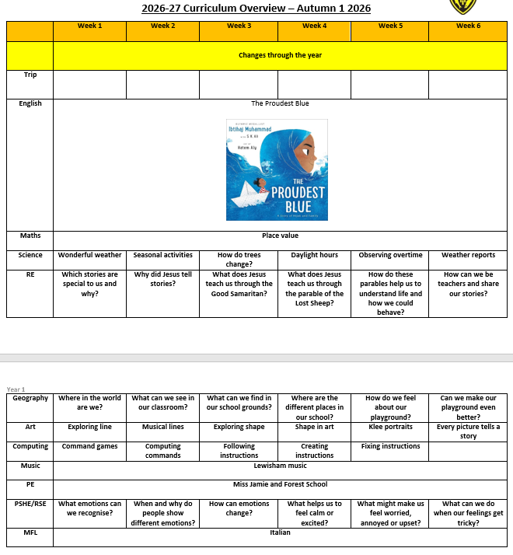
Autumn 1:

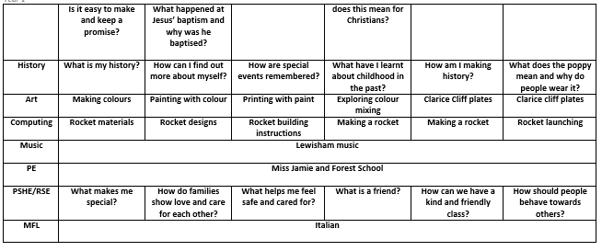
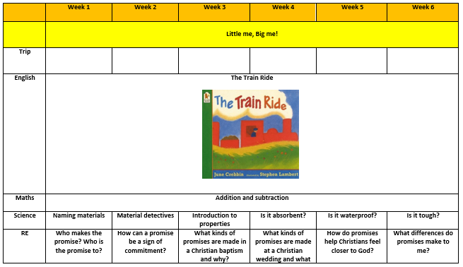
Autumn 2:

